Meet the Teachers
Mrs Holmes and Mrs Dean

Reading Books
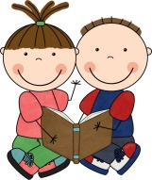
Book bags and reading books are to be brought into school every day. These will be changed on a Monday and Friday and a new book will be issued each time. Please do try to read the book or part of the book each day and sign or write a comment in their reading record every time they read with you at home.

The books in the first level do not have words, but they have lots of opportunities for extending speaking and listening skills and giving children experience of how a book works. Please discuss the pictures on each page in as much detail as possible. Ask your child to predict possible outcomes and to retell the story in their own words. We will allocate your child a word book when we feel they are ready, but please continue to read other stories to your child at home, as this is vital to your child’s development!

Show and tell
Show and tell is on Monday and Friday. Children can bring in something of interest to them to share with the class. Please note that these should not be toys.

Pocket toys
Children may bring in a small, pocket sized toy to play with at lunch time outside but these must be put into the box when in class.

P.E
P.E takes place on Mondays and Friday and children should have their full P.E kit (including trainers, spare socks, jumpers and tracksuit bottoms) in school at all times. P.E kits will be sent home at the end of each ½ term to be washed or replaced where necessary. Please also ensure everything is named including shoes, tights and socks to avoid anything going missing.

Pegs of Pride
In every classroom we have a ‘Pegs of Pride’ board. This gives every child an opportunity to display a piece of work, from home or school, that they are particularly proud of! Please encourage your child to bring pictures, writing, photographs of something they have done that is special to them for their peg.

Coat Zips
As the weather becomes increasingly colder, please try to teach your child to do up their own coat zip.

Busy fingers
Developing your child’s fine motor skills is imperative to developing the strength to write. We continue to welcome all parents to ‘stay and play’ in the classroom every morning to take part in ‘Busy Fingers’ with your child until 8.55am.
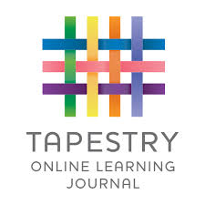
Tapestry – online journals
Please look out for a parent mail about a tapestry workshop we will be running to enable you to view what your child in learning at school and how you can send wow moments from home through our new online app!!

Mystery Reader
Please do sign up to be our ‘Mystery Reader’ in Shackadell. You can read a story of your choice to the class or talk to the children about your job, your culture or an interest that the children might enjoy.

If you have any questions about anything, please do not hesitate to speak to any member of the team before or after school.

The Shackadell Team

